How I made the circuits in Proteus
1. I went to the ‘Component mode’ tab and the P checkbox/icon and then searched the RES, VSOURCE and BATTERY and placed it in the sheet

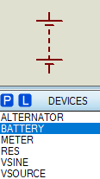
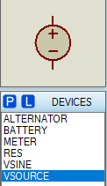
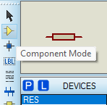
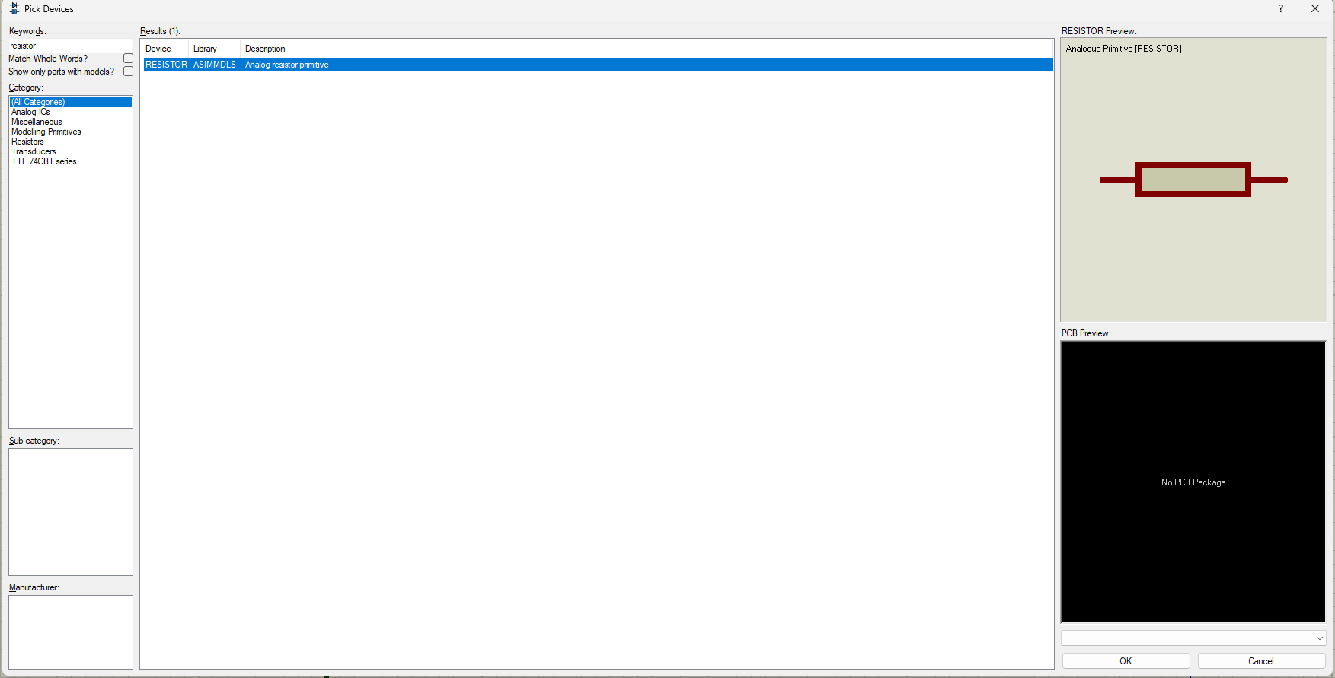
2. Then I went to ‘Instrument’ tab and drop the AC AMMETER and AC VOLTMETER in the sheet.
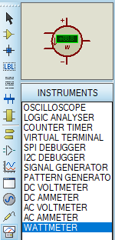
3. I then connected the resistors in the series by drawing a wire with mouse and changed the value of their resistances.
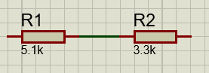
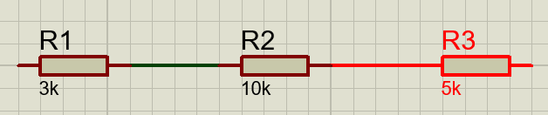
Circuit 1
4. Then I connected the positive terminal of the VSOURCE to R1 and grounded the negative terminal by dropping the ground from ‘Subcircuit Mode’ and also connected ammeter in series and connected it to ground.
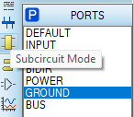
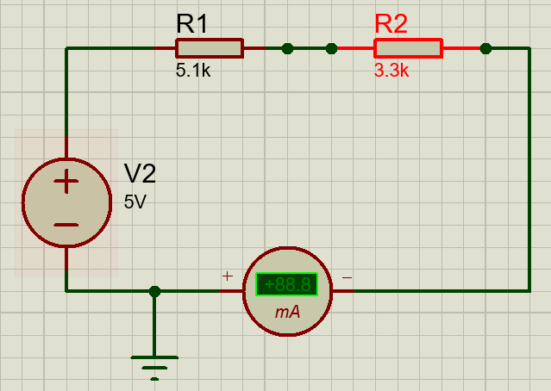

5. Then I connected the Voltmeter in parallel to R1 and R2.
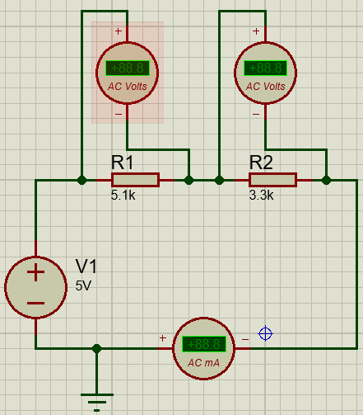

Circuit 2
4. Then I connected the positive terminal of the VSOURCE to R1 and grounded the negative terminal by dropping the ground from ‘Subcircuit Mode’ and also connected ammeter in series and connected it to ground.
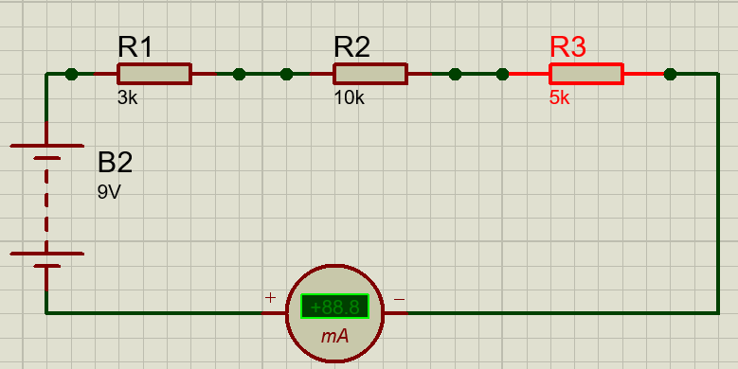

5. Then I connected the Voltmeter in parallel to R1, R2 and R3. 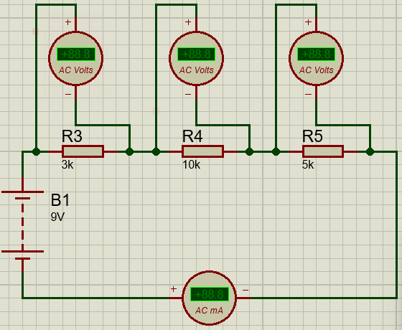
Outputs
Circuit 1
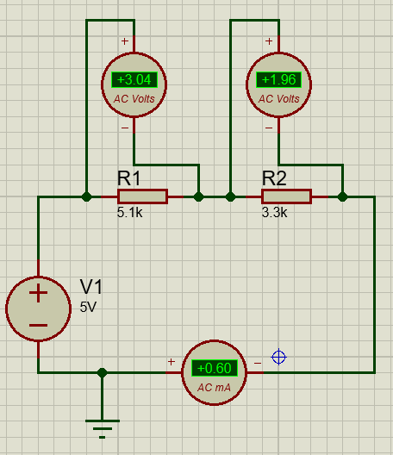

Circuit 2
